RETAIL WOMENS SCRUBS OF TOP AND BOTTOM SETS

$52.22

.

RETAIL MENS SCRUBS

OF TOP AND BOTTOMS SETS

$57.99

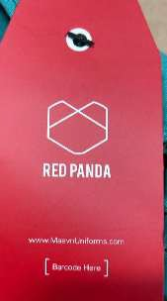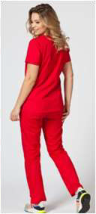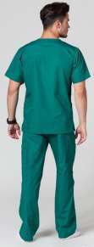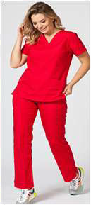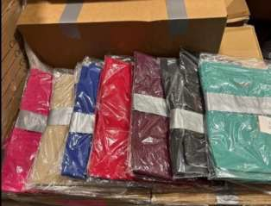

**THE ABOVE IS ONLY TO DEFFERENT SHOW COLORS**

ADDITIONAL PICTURES NEXT PAGE

Please see the varied breakdown below of the scrubs.

Small- 6,345 pairs, assorted colors

Medium- 8,505 pairs, assorted colors Large- 5,865 pairs, assorted colors

X Large - 4,770 pairs, assorted colors XX Large- 2,460 pairs, assorted colors

The pairs are packed: tops in one box and the

bottoms in another box but the two boxes are taped together to make sets. One size, one color in the

boxes. I am told most are packed 12 per box.

All boxes are labeled.

Assorted sizes and colors - tops and bottoms 27,945 units plus about 54,355 units not paired.

All are new boxed but may not be in original factory boxes.

Total units roughly 82,300

Please see some pictures attached, 50 pallets total. Will be 2 truckloads.

FOB NJ

a **!41**

N11T-1

Cl"'-# **12_ 1!**

**ij;c,i;.¥1,fil.l**

* ii!. T **Jo• O)..TI** TER
* **C**TTl!>M•III.Q<CO

**tcl'OII**

E•Ca

■**r**

.....

**1111111111**

111i::r,..,

. M.

jot wt• --n,,, II M■ t

-.r,;,. -■•'t" ,,.,.,.oiillo1o1.. ft II

* + l:J rea-,oo IIMZ'lr

O'tc,gafal :maD.ll:i.-,

